**Deliverable 1**

**Team Name: WebIt**

Krishna Viradia, Courtney Burns, Sara Nazir, Wubnyonga Tete,

Theresa Tomilson, Mehak Uddin, Nuri Ousman

**IS 436: Structured Systems Analysis and Design**

**Due Date:** 2/21/19

**Systems Request - Building a Web Based Application**

**Project Sponsor :**

Owner:Vicky Tawle

Business: Vicky’s Event Planning Company

Phone: 240-467-0325

Email: N/A

**Business Description**

Vicky Tawle, an event planner, currently manages events such as baby showers, birthday parties, funerals, weddings and more. Depending on a customer’s request, she provides services such as venue booking, catering, music, photography, decorations and more. Currently, she records all of her event information (client information, event type, services rendered, cost, etc.) in a ;physical book. This manual form of recordkeeping has been unreliable, causing Tawle inconsistencies in invoices, customer information and needs, and organization. In order to help manage these problems, a database will be constructed by WebIt to keep track of customer information, event information, and services requested per event. Transitioning from a paper-based recordkeeping system to an online, updatable database will help Tawle manage her business efficiently and effectively, allowing her to access customer information, events, and services requested in a timely and accurate manner. WebIt will design a dynamic web-based application that will integrate the database containing Tawle’s business information, allowing the user to interact with the database via the front-end.

**Business Need:**

This project has been initiated to create an online database accessible by Vicky Tawle, effectively eliminating her previous use of a paper-only system. The application will allow Tawle to store customer information, service costs, invoices, and event information. Currently, many of Tawle’s competitors have moved away from traditional pen and paper bookkeeping, opting to rely on operational databases and computer systems. In order to remain competitive, Tawle has decided to transition to an online database with the goal of utilizing a centralized and consistent recordkeeping system, allowing her to save time with calculations and scheduling and up her efficiency by large margins.

**Business Requirements:**

Tawle’s main issue was consistency and reliability of her recordkeeping. In order to satisfy the business needs of this project, a web-based application with an updatable back-end database will be created. The database will store and calculate all pertinent information regarding invoices, event dates, customer information and services rendered. The user will be able to view and schedule upcoming events, the services required, and customer information per event. The database will provide automatic calculation of the cost for each event, an updated schedule based on user input, eliminating the need for Tawle’s manual calculations and updates. The application will also provide online accessibility, allowing Tawle to access business information from different locations.

**Business Value:**

Since the application will be web-based, the database and its contents will be

accessible to Tawle anywhere she goes so long as she has Internet access. The

application will provide Tawle with immediate accessibility of information and increased organization as the user moves from paper to technology. By creating an application that contains customer and invoice information, the time the user will spend recording transactional and customer information will decrease. The database will perform calculations on its own, reducing the time Tawle would have otherwise spent calculating expenses, profit, etc. by hand. By eliminating paper-based recordkeeping and calculations, Tawle will have more time to spend on planning more events and interacting with her customers. By utilizing the web-based application, the user can expect to experience a 15% increase in productivity and a 50% increase in accuracy and consistency of invoice calculations.

**Special Constraints:**

* While this application is web-based, the intended users for this database are the client, Vicky Tawle, and anyone else she deems necessary to have access to the database.
* The project has to be completed within three months (the duration of the course).

**Feasibility Analysis**

**Technical Feasibility:**

MySQL will be used to develop the database and PHP will integrate the database into the web-application. The software tool phpMyAdmin will be used to integrate the MySQL database into the application. We will be using WordPress.com to create the dynamic front-end of our web-application. In order for the user to be able to access the web-application they will need a computer device, one that should be able to at least sustain moderate web-browsing, and Internet access. There will be two main developers of the database and web-application with five other members contributing if need be. However, once the database and application is developed, it will be up to the user to maintain the information within it. Updating, inserting, or deleting any information will be left up to the user, not WebIt. The user will be able to access these functions via the dynamic web-application.

**Organizational Feasibility:**

The company’s owner, Vicky Tawle, will be taking on the majority of the work behind the website and the upkeep of the database. Since she is a small business owner of an event planning company, her only employees include herself and any outside vendors that she chooses for a particular event. The database would be relatively small and simple due to the size and nature of her work, so she would manage it all through the application that Webit plans to build for her. Her workload should only increase due to an increase in customers. She will be managing her entire company from the application. She will act as business owner, project manager, database owner, and many other roles through the use of WebIt’s application.

**Economic Feasibility**

Computer System (One Time Cost). Most likely to be the bulk of the cost. The computer needs to be able to adequately run a MySQL Server. The minimum requirements for MySQL Server are 2 cores, 2GB of RAM, and 500MB of disk space. Estimated Cost: $500. MySQL Software. MySQL offers open source software for free.

|  |  |
| --- | --- |
| **Tangible Benefits**   * A new scheduling system that improves efficiency. * Eliminates paper-based recordkeeping system * With this new system, production delays are also eliminated. * Decrease in customer complains and calls | **Intangible Benefits**   * A user friendly system that improves job satisfaction * Tracking invoice will help in marketing decision making. * This new web interface increases efficiency, thus enhances the Tawle’s image. * Increase in customer satisfaction |

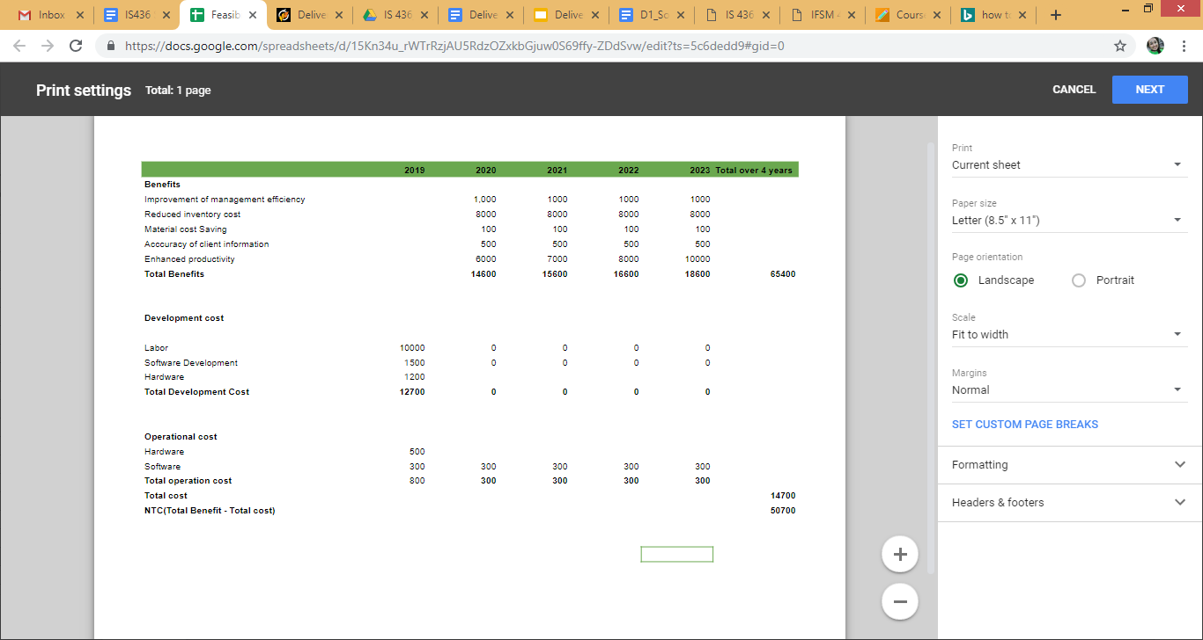

**Team Members and Roles**

* **Krishna Viradia -** Quality Assurance Analyst
  + *Email:* kris26@umbc.edu
  + *Bio:* Senior at UMBC pursuing a B.S. in Information Systems. Also, working at Mosaic Learning as a Quality Assurance Intern. Experience in writing and executing manual text scripts on integration, staging and production on various different projects through JIRA and qTest.
* **Courtney Burns -** Business/System Analyst
  + *Email:* court12@umbc.edu
  + *Bio:* Senior in the Information Systems Undergraduate Program at UMBC. Experience with system analysis, data quality concern management and solution development, customer relationship management. Project leadership experience through work as a student project lead in the Department of Information Technology at UMBC. Intermediate knowledge of front and back-end web development.
* **Sara Nazir -** Quality Assurance Analyst/Editor
  + *Email:* snazir2@umbc.edu
  + *Bio:* Senior in Information System at UMBC. Experience with front end development as well as analyst and quality assurance roles/skills acquired through my internship. Strong writing and speaking skills
* **Wubnyonga Tete -** Project Manager
  + *Email:* wtete1@umbc.edu
  + *Bio:* Information Systems undergraduate student at UMBC. A senior and last semester at UMBC as an undergraduate. Intermediate knowledge in front-end web development. Experience in teamwork and leadership role. Excited to take up this role to learn and perfect myself.
* **Theresa Tomilson -** Developer
  + *Email:* there2@umbc.edu
  + *Bio:* Senior in the Information Systems Undergraduate Program at UMBC. Experience coding and developing the back-end for databases as well as front-end compatibility.
* **Mehak Uddin -** Developer
  + *Email:* muddin1@umbc.edu
  + *Bio:* Senior at UMBC pursuing Information Systems graduating in Spring 2019. Working at Cotiviti as an Associate Data Manager Intern. Duties include: Maintaining, collecting, analyzing, and distributing data to ensure adequacy, accuracy and legitimacy.
* **Nuri Ousman -** Business/System Analyst
  + *Email:* nu2@umbc.edu
  + *Bio:* Senior Information system major with a Mathematics minor. Intermediate Experience in database development and coding.

**Meeting Times/Tentative Schedule**

This schedule is subject to change as the project proceeds. More or less meeting times might be required as agreed upon by the team. Class dates are also meeting dates, but it is not included in the schedule. Emergency meetings can be scheduled when a majority or at least 3 members are free to meet

|  |  |
| --- | --- |
| **DAY** | **DATE** |
| Wednesday | 02/13/2019 |
| Monday | 02/18/2019 |
| Wednesday | 02/20/2019 |
| Wednesday | 02/27/2019 |
| Wednesday | 03/06/2019 |
| Monday | 03/11/2019 |
| Wednesday | 03/13/2019 |
| Monday/Wednesday | Same as above |
| Wednesday | 05/01/2019 (Project Completion) |

**Kanban Flow**

